Modelling a Geothermal Vaporiser: A First Step Towards a Digital Twin

Theo Brehmer-Hine, Wei Yu, Brent Young*

Chemical and Materials Engineering Department, The University of Auckland, New Zealand

*b.young@auckland.ac.nz

Abstract

‘Digitalisation’ is a current mega-trend for assisting industry decision-making. The geothermal industry is not immune to this trend, given the strong incentives to improve efficiency whilst maintaining product quality, safety and productivity. The ‘digital twin’ can be considered as one of the core concepts of digitalisation, and yet it is still at the conceptual stage for many manufacturing operations. The first step in digital twin implementation is to build digital models since they are the essential components of digital twins. However, how to select suitable models from many different types of models of different fidelity for the geothermal industry is an open question which has not yet been addressed. In this paper, we will compare two modelling approaches: first principles (using Python) and hybrid process simulation (using Aspen HYSYS) for simulating industrial-scale geothermal vaporizer dynamics. The development of these one-way connection models is useful as a first step towards a digital twin and allows a plant model with more flexibility for vaporiser modelling.

A comparison was made between models and the tools used in their development based on attributes of performance, availability, ease of use and model fidelity. The models from both approaches showed adequate predictions at multiple steady-state conditions. However, the Aspen HYSYS model performed slightly better. There were only slight differences in prediction performance and processing speeds. For the availability and ease of use of these tools, a trade-off would need to be made in deciding which modelling approach to use, weighing a monetary investment in using Aspen HYSYS against the time investment in building the first principles model.

**Keywords**: Digital twin, Model Fidelity, Vaporiser

* 1. Introduction

To meet New Zealand’s (NZ’s) goal of net-zero greenhouse gas (GHG) emissions by 2050, development into disruptive decarbonisation technologies in the process heat sector will be required. Digital twin (DT) technology shows the potential to improve energy efficiency and reduce greenhouse gas emissions. As evaporators and vaporisers are essential to NZ industries such as the dairy processing industry and the geothermal power industry, implementing DT technology on evaporators or vaporisers should be considered by all industries using these units.

A Digital Twin (DT) in a manufacturing context consists of a virtual representation of a production system ‘twinned’ with the physical system. A DT can run simultaneously with the physical system, whereby, an automatic and bi-directional connection of data flows between the physical and virtual systems. The role of DTs in manufacturing systems is to predict and optimise the behaviour of the systems in real-time. Sub-categories of digital shadows and digital models exist at lower levels of integration between model and system. A digital shadow is where the automatic flow of data is unidirectional from the physical system to the virtual system, while a digital model has no automated flow of data between the systems (Kritzinger *et al*., 2018). A subtle adjustment to this classification was made by Yu *et al*. (2022), where the term digital manager is used to describe DTs with a two-way connection. This distinction is made to encompass DTs used in plant control systems rather than in plant design or plant retrofits.

The first step in DT development is in building a digital model of a system. In this work, an investigation was conducted into various models of evaporator and Organic Rankine Cycle (ORC) systems. The modelling approaches can be broadly categorised into first principles, ‘black box’ and ‘grey box’ modelling. A significant portion of the models seen in the literature have been developed using commercial process simulators such as Aspen Plus, Aspen HYSYS, VMG Symmetry, gProms and Modelica. Models developed using these software programs display a process flow diagram of this system itself and are capable of modelling both steady-state and dynamic systems. This is similar to first principles (FP) based models developed in software such as MATLAB, however, in FP models no visual representation of the system is typically shown. A significant number of empirical (‘black box’) models have also been developed for these systems in steady state and dynamics, however, these also lack visual representations. Of these models, only Soares *et al*. (2019) developed a model with a connection between the model and a system.

This paper is organised as follows. In Section 2, the vaporiser's basic information is provided. In Section 3, two modelling approaches: first principles and simulation (Aspen HYSY) are discussed. In Section 4, the performance of these models will be compared based on their dynamic response performance as while as attributes of performance: performance, availability, ease of use and model fidelity. Finally, the conclusions of this paper are presented.

* 1. System description

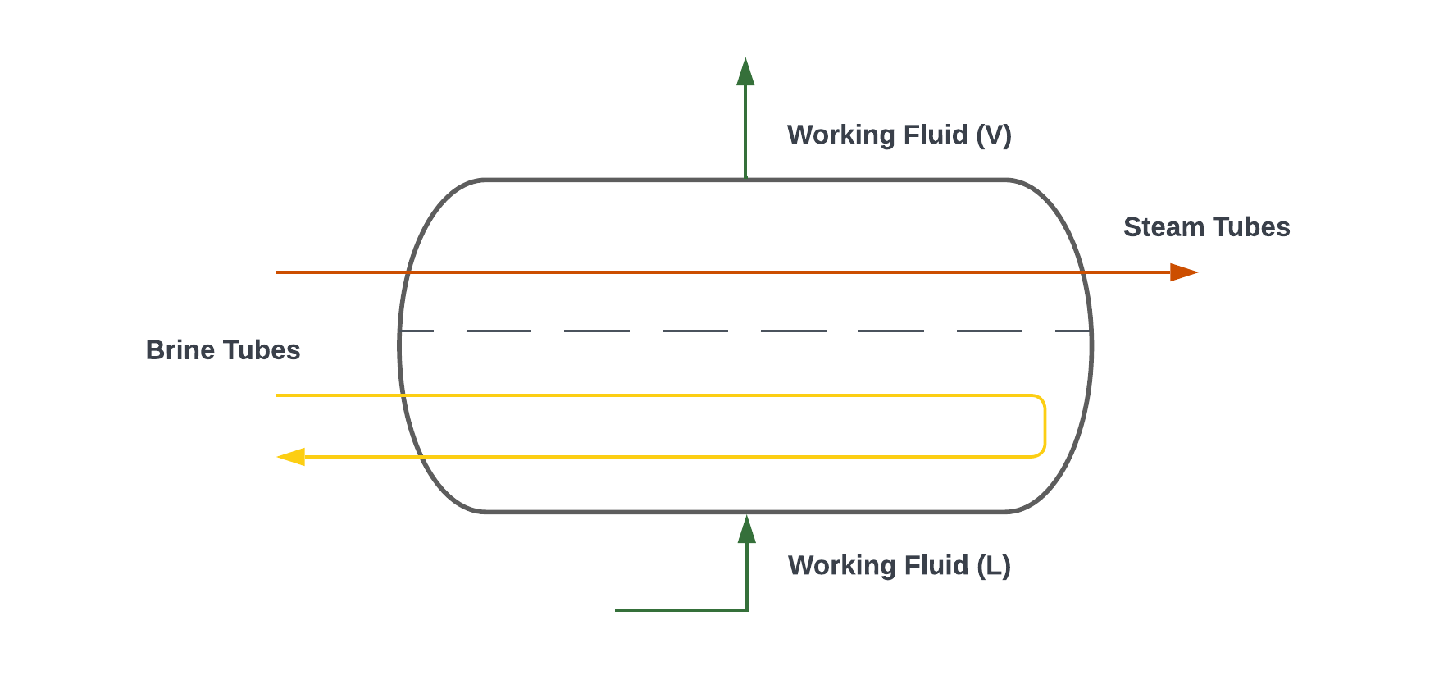The vaporiser belonging to one NZ geothermal binary plant is investigated in this paper. The plant can generate a gross net power of 35 MW during normal operation. The system uses normal pentane as the working fluid. The vaporiser has multiple tube sets, for brine and geothermal vapour. The vaporiser configuration is shown in Fig. 1. The brine tubes have two passes, which carry out the sub-heating and a small amount of vaporisation of the working fluid, while the geothermal vapour carries out the remainder of the vaporisation and a degree of superheating of the working fluid in a single pass. The working fluid flows perpendicular to the flow of the geothermal fluids.

Figure 1: The vaporiser shell and tube configuration

The composition of a geothermal fluid is strongly related to its thermodynamic properties and therefore requires a ’fit for purpose’ equation of state to be modelled most effectively. With access to the geothermal plant’s compositional data, it was noted that the vapour is largely comprised of water with a small amount of carbon dioxide. Minuscule amounts of methane, ammonia, hydrogen sulfide, hydrogen and nitrogen were also shown in this analysis, however, the mole fractions were less than 0.0001 and it was therefore deemed unnecessary to include these components. The brine is assumed to be pure water as the changes to the thermodynamic properties of the fluid are relatively small when compared with vapour. The simplified composition (mole fraction) of the separated vapour used in the following models is shown in Table 1.

Table 1: Simplified composition of the separated geothermal vapour

|  |  |
| --- | --- |
| Component | Composition (Mole fraction) |
| Water | 0.985 |
| Carbon Dioxide | 0.015 |

* 1. Vaporiser Modelling

A vaporizer and associated models of the plant were developed in Aspen HYSYS, and a separate vaporizer model was also developed in Python. All models were developed and tuned against snapshots of the plant's steady-state conditions. The vaporiser models were then transitioned to dynamic simulations to study their dynamic responses.

* + 1. Aspen HYSYS model

[Aspen HYSYS](https://www.aspentech.com/en/products/engineering/aspen-hysys) is widely used in both industry and academia in analysing process engineering applications in steady state and dynamics. As such, Aspen HYSYS was selected for the development of a dynamic model of the vaporiser. In addition to this, a plant model of the working fluid cycle was developed in a steady state.

There is no unit operation provided by Aspen HYSYS that replicates a multiple tube-set heat exchanger. The approach taken is based on the method developed by Proctor *et al*.(2016), where two coolers were used to model the heat transfer of each tube-set in addition to a heater modelling the heating of the shell side. The LMTD was calculated for each section and these were multiplied by the static UA values calculated based on plant data. The resultant heat flows were added and used for specifying the shell-side heater. The Aspen HYSYS schematic is shown in Fi*g.* 2.

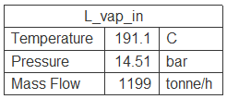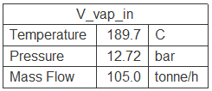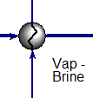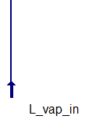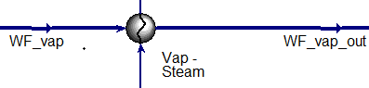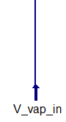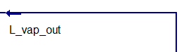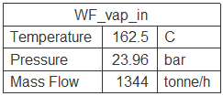

Figure 2: The Aspen HYSYS schematic of the vaporiser model. The ‘Vap-Brine’ and ‘Vap-Steam’ refer to the brine and geothermal steam of the vaporiser.

Careful consideration must be taken in selecting the Equations of State (EOS) as this is necessary for an accurate model as it handles the calculation of state variables under given conditions. Modelling a vapour mixture of water and carbon dioxide can be difficult due to the complex interactions between polar water and non-polar carbon dioxide molecules. After testing different EOS packages, the Cubic-Plus-Association (CPA) EOS was selected based on model prediction accuracy.

* + 1. First principles (FP) model

The FP model was developed in Python using the solve_ivp integrator from SciPy integrate, where the explicit Runge-Kutta method of order 3 (2) was used in solving the ODE. The model utilised Coolprop for the thermodynamic package. The governing equations of the vaporiser are the working fluid mass and energy balance, the geothermal fluid mass and energy balance, and the energy balance of the wall. The following assumptions were made for simplification of the solution of the differential equations:

* No axial heat conduction, only heat transport in the working fluid, wall or geothermal fluid.
* Spatially constant fluid pressure p(t).
* The three tube passes are each discretised into a number (n) of lumped sub-volumes, each of which corresponds to a sub-volume of the shell.
* Static geothermal fluid and working fluid temperature profiles for each section.
* Inlet and outlet enthalpy are averaged to approximate the temperature of the section.
* The mass flow rate for each fluid is equal in all sections.
* The geothermal vapour composition is assumed to contain CO2 and water.

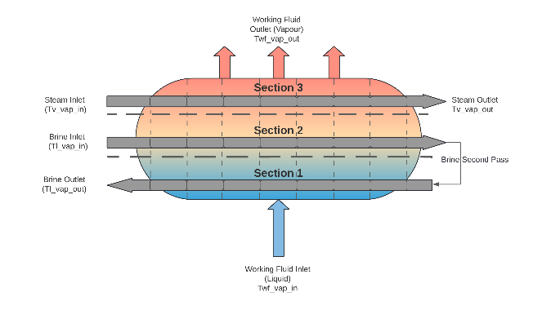In developing this model, the working fluid was segmented into three vertical sections. These corresponded to the three passes of geothermal fluid through the vaporiser. A diagram describing this configuration is shown in Fig. 3.

Figure 3: Configuration of the Python FP model with a discretisation of seven sub-volumes

* 1. Results and Discussion
     1. Model prediction comparison

To test the dynamic response of all the outlet streams of the vaporiser, the working fluid flow rate was increased from 1230T/h to 1310T/h. This result is shown in Fig. 4. The FP model appears to show a comparatively faster response, which is most evident in the working fluid’s response. The response of Aspen HYSYS, in addition to being slower, appears to be of a comparatively higher-order derivative. This is thought to result from the more comprehensive hold-up and pressure specifications used in Aspen HYSYS’s heat exchanger model which mimics physical systems. This could be addressed by implementing more rigorous mass and momentum balances into the ODE or by tuning the model dynamically (e.g., Pili *et al*., 2017; Huster *et al*., 2018). When comparing the FP model against the outlet temperatures produced in Aspen HYSYS, a Root Mean Squared Error (RMSE) of 0.124◦C, 0.401◦C and 0.250◦C was shown for the brine, vapour and working fluid respectively. The mean average percentage error (MAPE) was 0.039%, 0.211% and 0.093% for brine, vapour and working fluid, respectively.

Figure 4: Step change of the working fluid (A) and brine (B) flowrates and the temperature response of the vaporiser for the Aspen HYSYS model and the Python FP model

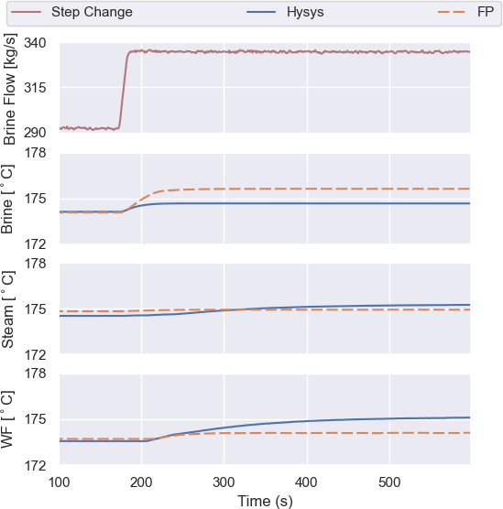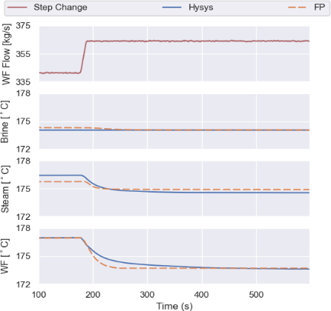

* + 1. Model comparison

The comparison criteria are based on Alford *et al.*, (2022). This includes the model performance availabilityand ease of use of the software. The comparison criteria are also extended to include the aforementioned model fidelity framework outlined by Yu *et al.,* (2022)*.* The summary of the comparisons is listed in Table 2.

Performance: The model performance considers prediction accuracy and the processing time required.

Availability: The availability considers the accessibility and the monetary investment of these software tools. Python and CoolProp are both available worldwide at no cost, while an Aspen HYSYS dynamic license, though also globally available, costs approximately 85% of a process engineering graduate’s annual salary in New Zealand.

Ease of use: This considers the difference in time, effort and skill requirements of developing each model. For the entire FP model, a relatively small percentage of the written code is used for the calculation of heat transfer, whereas the remaining code is used in setting up the thermodynamic properties and state variables. This setup includes the developed empirical equations and CoolProp. This differs from the Aspen HYSYS model which has a wide range of easily accessible thermodynamic property packages.

Model fidelity: The model fidelity framework proposed by Yu *et al*., (2022) was used which includes three distinct attributes of a Digital Twin: looks-like, behaves-like and connects to. Both models developed have been validated against multiple steady-state data points and are capable of modelling dynamically. These models therefore would be classified as 3-D in the behaves-like attribute.

* 1. Conclusions

Two models: a plant model of the ORC cycle developed in Aspen HYSYS and a first principles-based model of the vaporiser developed in Python using a discretisation approach were developed. These models were used to compare the advantages and disadvantages of different modelling approaches for DT implementation. This was used to further understand the key strengths and limitations of the software tools used, and the model development process. We conclude that there were slight differences in prediction performance and processing speeds. For the availability and ease of use of these tools, a trade-off would need to be made in deciding which modelling software to use, weighing a monetary investment in using Aspen HYSYS against the time investment in using Python.

Table 2: Summary of the comparisons of the FP and Aspen HYSYS model attributes

|  |  |  |
| --- | --- | --- |
| **Model Attribute** | **Aspen HYSYS** | **First Principles** |
| Average Prediction Error  of Steady State | 0.065 | 1.773 |
| Simulation Speed (s) | 93.09 | 80.09 |
| Availability | Available worldwide | Available worldwide |
| Software Cost | 85% of a graduate process engineer’s annual salary | Freely available |
| Set-up (thermodynamic  properties) | Built-in to the software | Set-up using CoolProp |
| Flexibility of Heat transfer | Less flexible, easily used if the unit operation is available | As the heat transfer equation is formulated  the high degree of flexibility |
| Development Time  (Estimate) | 1 week | 4 months |
| Quality Assurance/Robustness | Tested commercially by a professional team of people | Tested by one person |
| Behaves-like | 3D | 3D |
| Looks-like | 2D | 2D |
| Connects-to | 1D | 1D |

Acknowledgments

This research has been supported by the programme “Ahuora: Delivering sustainable industry through smart process heat decarbonisation”, an Advanced Energy Technology Platform, funded by the New Zealand Ministry of Business, Innovation and Employment.

References

M. Alford, I. Udugama, W. Yu & B.R. Young, B. R., 2022, Flexible digital twins from commercial off-the-shelf software solutions: A driver for energy efficiency and decarbonisation in process industries? *Chemical Product and Process Modeling*, 17(4), 395-407.

W. Kritzinger, M. Karner, G. Traar, J. Henjes & W. Sihn, W., 2018, Digital Twin in manufacturing: A categorical literature review and classification. *In IFAC-PapersOnLine*, 51(11), 1016–1022.

M. J. Proctor, W. Yu, R. D. Kirkpatrick & B. R. Young, 2016, Dynamic modelling and validation of a commercial scale geothermal organic Rankine cycle power plant. *Geothermics*, 61, 63–74.

R. M. Soares, M. M.Câmara, T. Feital & J. C. Pinto, 2019, August. Digital Twin for monitoring of industrial multi-effect evaporation. *Processes*, 7(8), 537.

W. Yu, P. Patros, B. R.Young, E. Klinac & T. G. Walmsley, 2022, Energy digital twin technology for industrial energy management: Classification, challenges and future. *Renewable and Sustainable Energy Reviews*, 161, 112407.